Evaluator: Pontus Svensson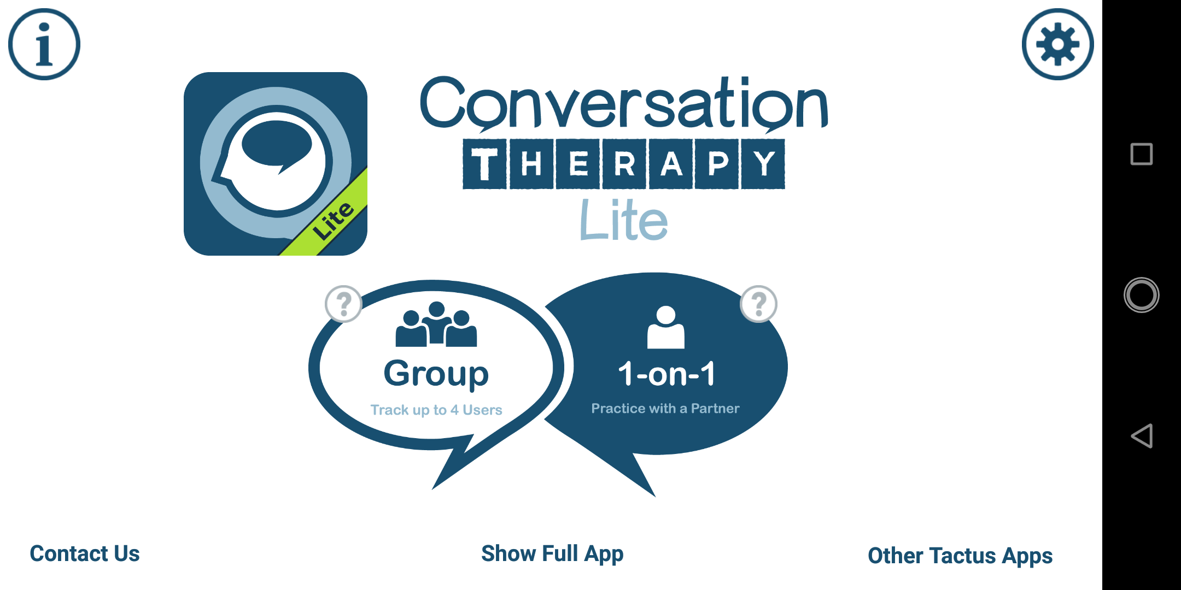

Reviewer: Leonardo Iwaya

DATE: 26/03/2024

Task: Play the group activity game for speech therapy.

In the given task, the user is supposed to have a therapy session in the form of a conversation.

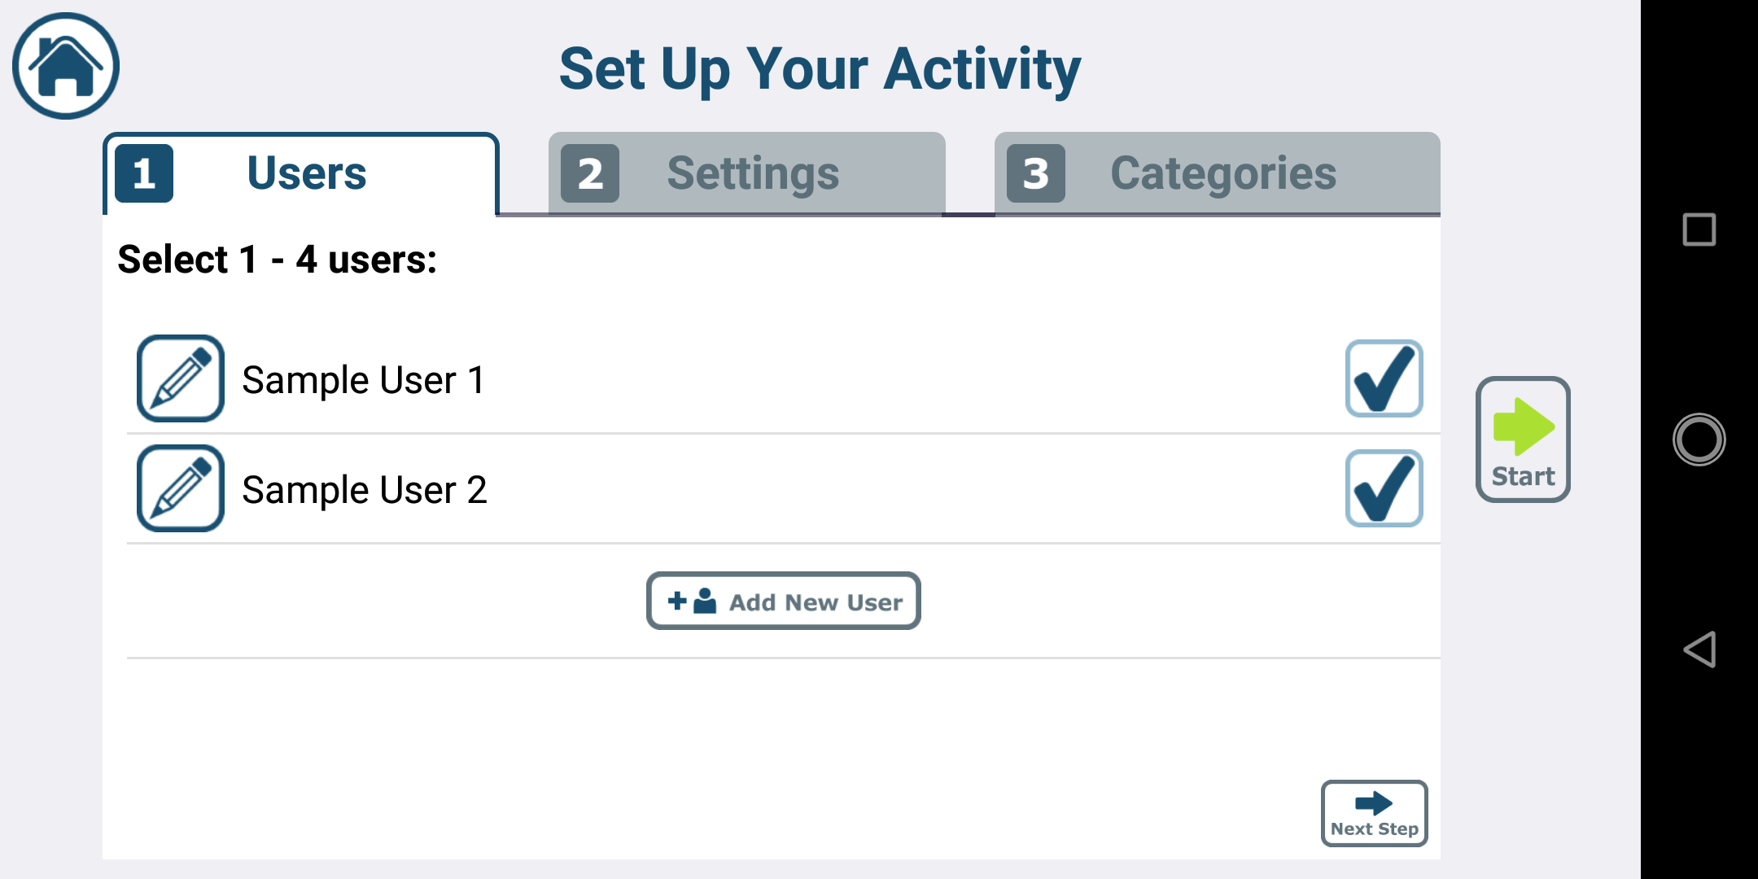

1. The user first has to set up their activity; see the three screenshots to the right and below for clarification. For someone new to the app, this can be confusing and overwhelming. As seen from the screenshots, there is no further information to explain the activity setup, which would violate heuristic number ten, **help and documentation**.

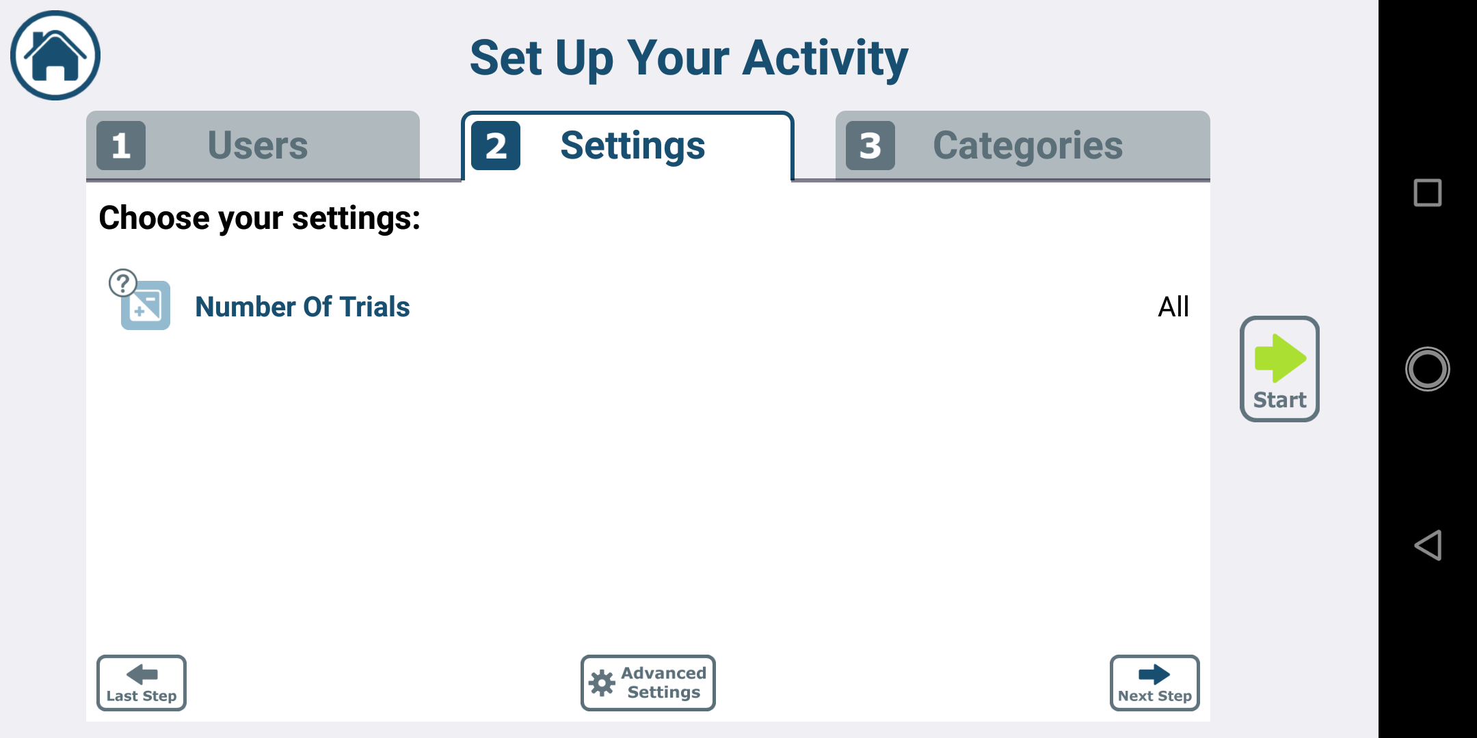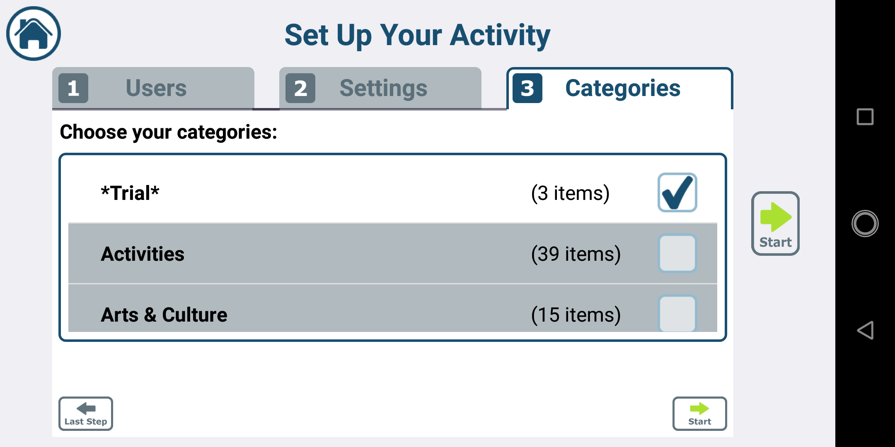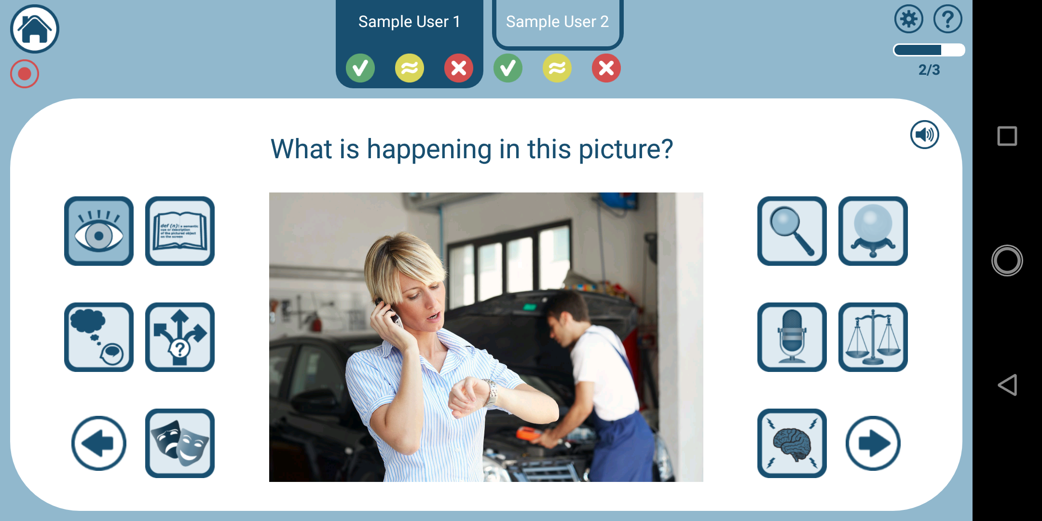

1. What the user sees after starting the game can be seen on the screenshot to the right. The interface is quite confusing as several buttons can be pressed, but there is no explanation as to what they do. This would violate heuristic “**recognition rather than recall”** as the memory load on the user should be reduced by having important information visible.